BeSpoked Bike Tracking Application:

All the requested in the requirement document is complete. Somehow form validation is not working. It could be some issues Asp.net mvc jquery bundle. I did not add Error handling, and logging.

# Architectural Design:

Front End -> Rest API -> Repo (Infrastructure)

# Detailed Design:

Front End: ASP.NET MVC, c#, JQuery, JavaScript, Bootstrap, Ajax, mapper functions to view models

Middle tier: Web API, C#.Net, Named BusAPI (As it is requested as tier, I have decided to go for Rest API). DTO are poco classes

Infrastructure: Repository Pattern, Entity Framework, Linq, Abstraction DTO are poco classes, mapper functions DBContext

# Sql Scripts:

Sql Scripts for table schema and insert data

# DB Diagram:

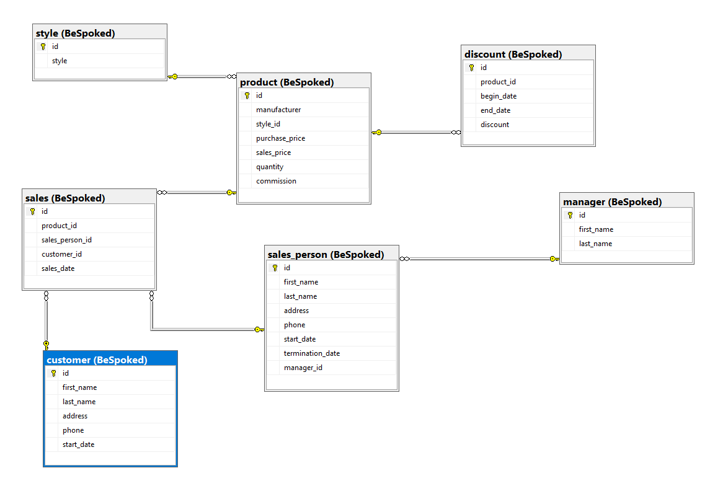

Screens:  
